1. Create one jenkins job using the below code and create three stages.

stage1: Git clone to download the source code.

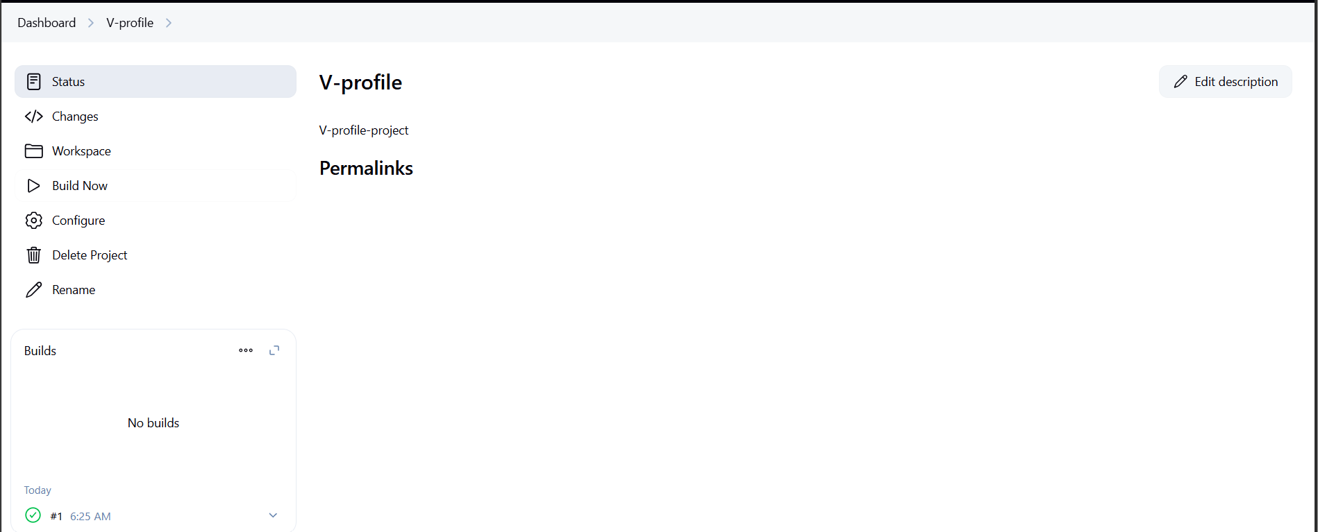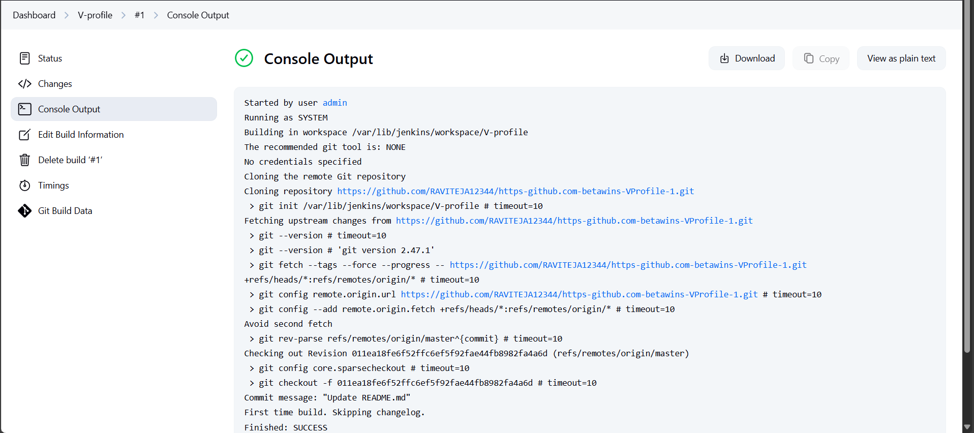

stage2: Sonarqube Integration to check the quality of code

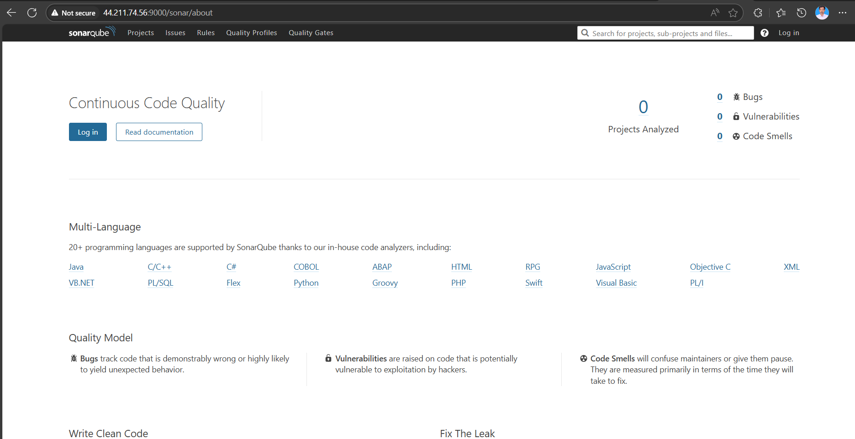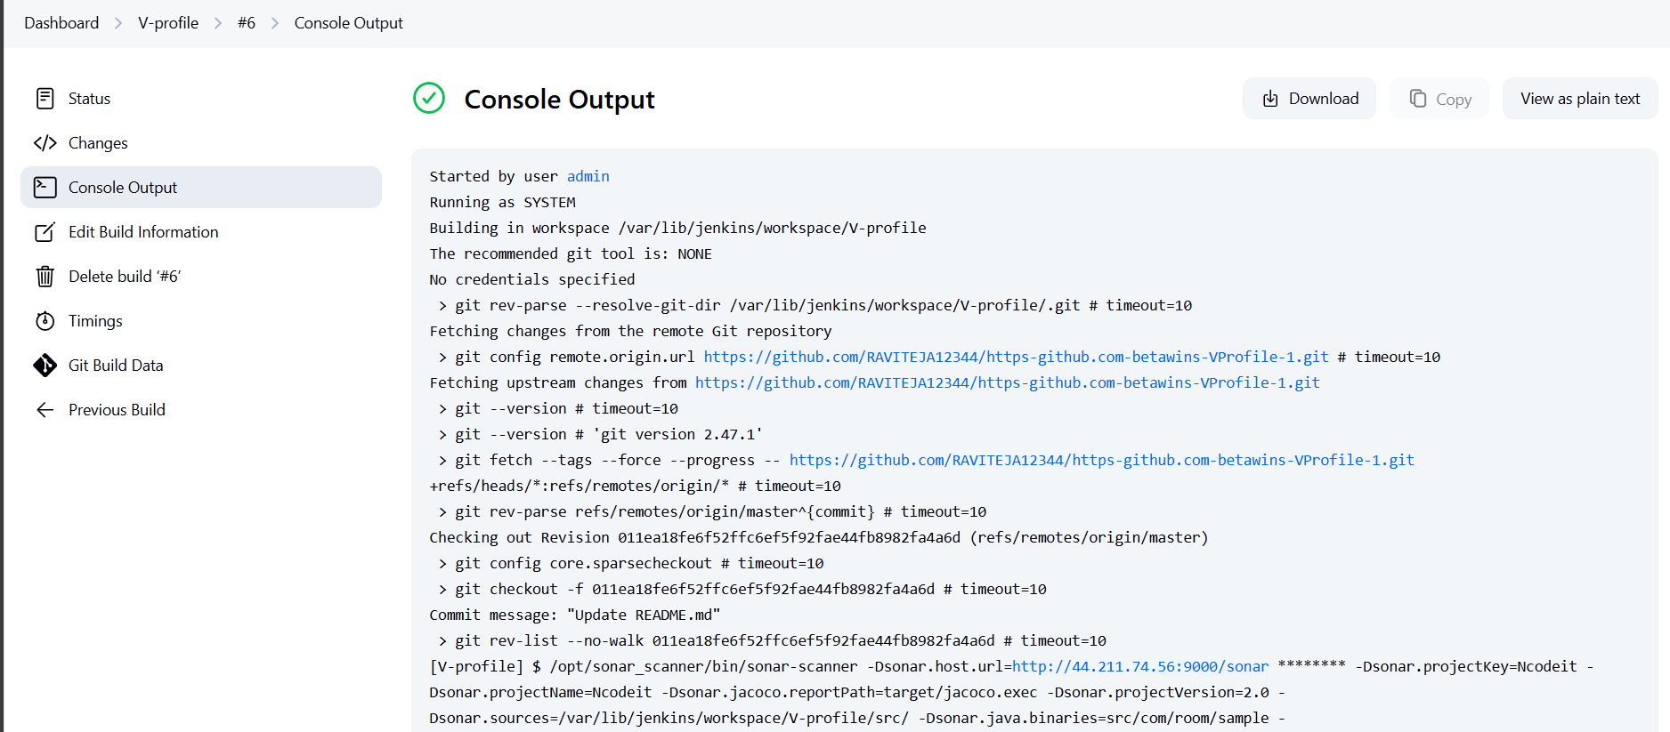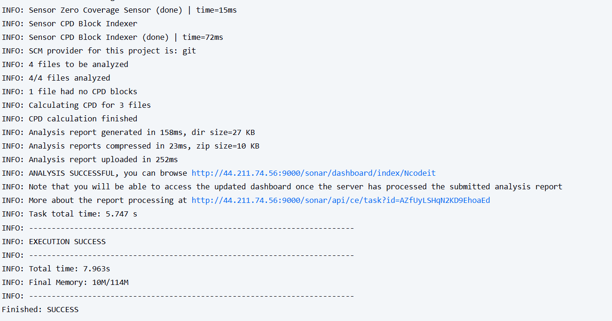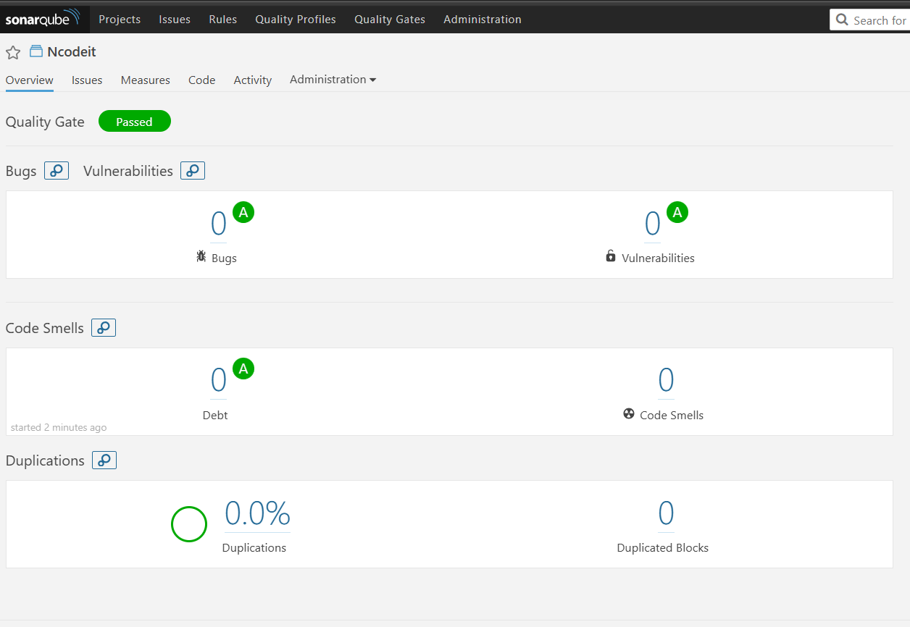

stage3: Slack Integration to send the alerts to slack.

URL: <https://github.com/betawins/VProfile-1.git>

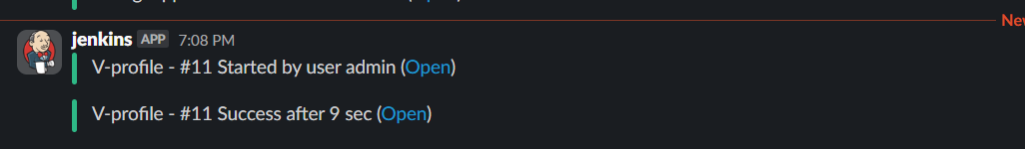

1. Create one jenkins job using the below code and create three stages.

stage1: Git clone to download the source code.

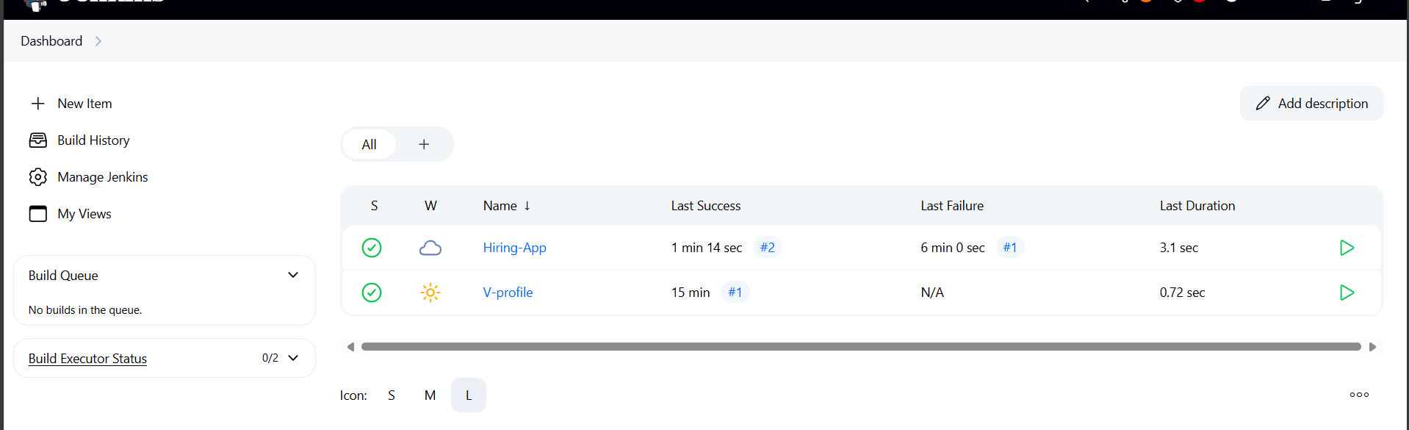

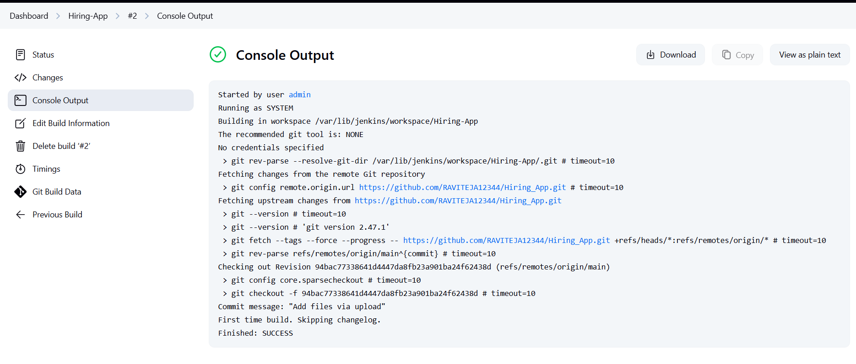

stage2: Sonarqube Integration to check the quality of code

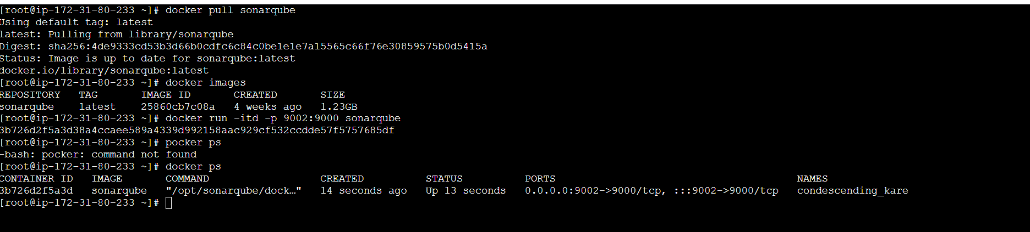 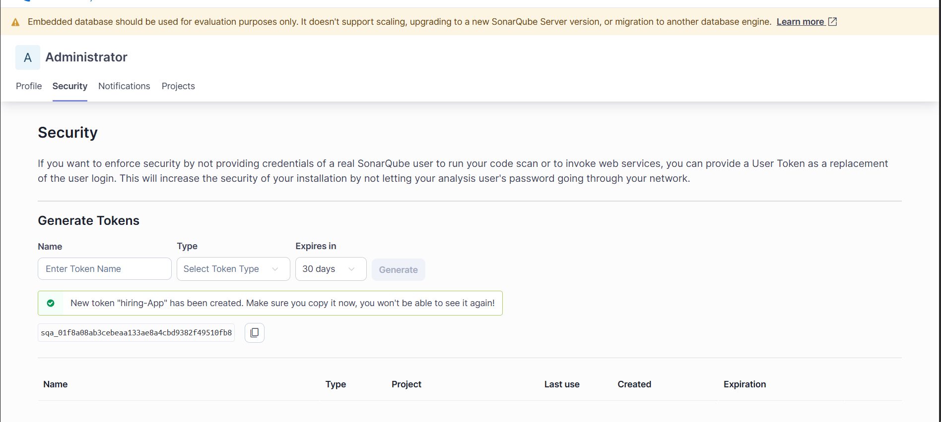 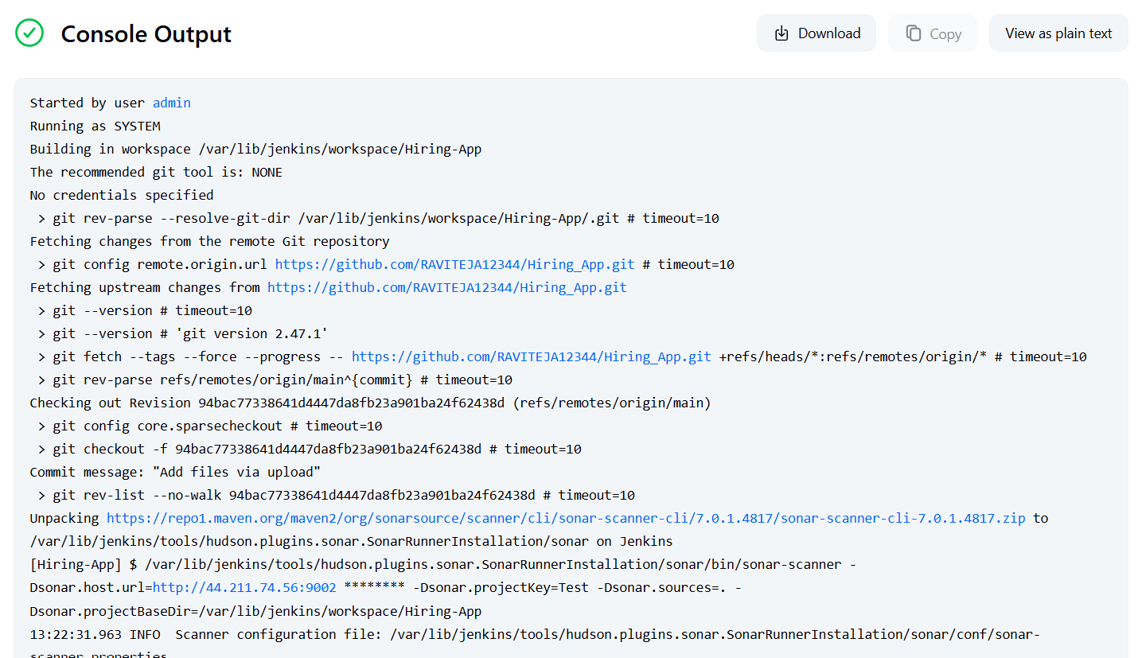 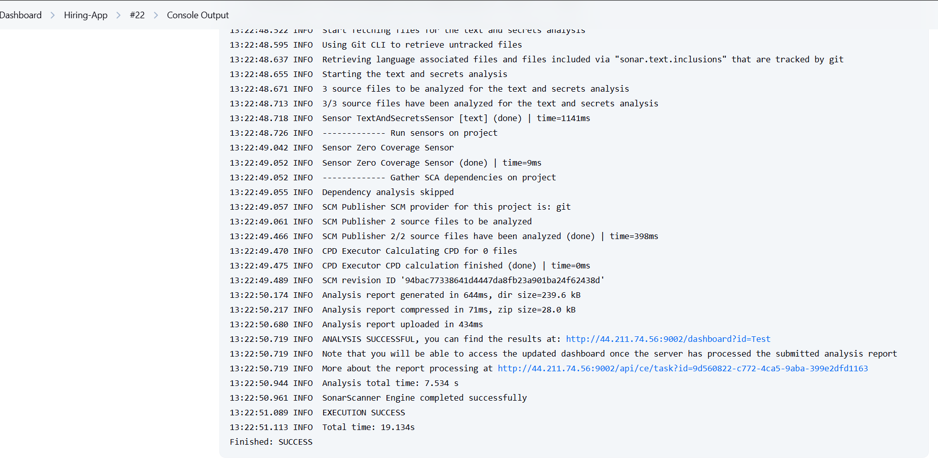 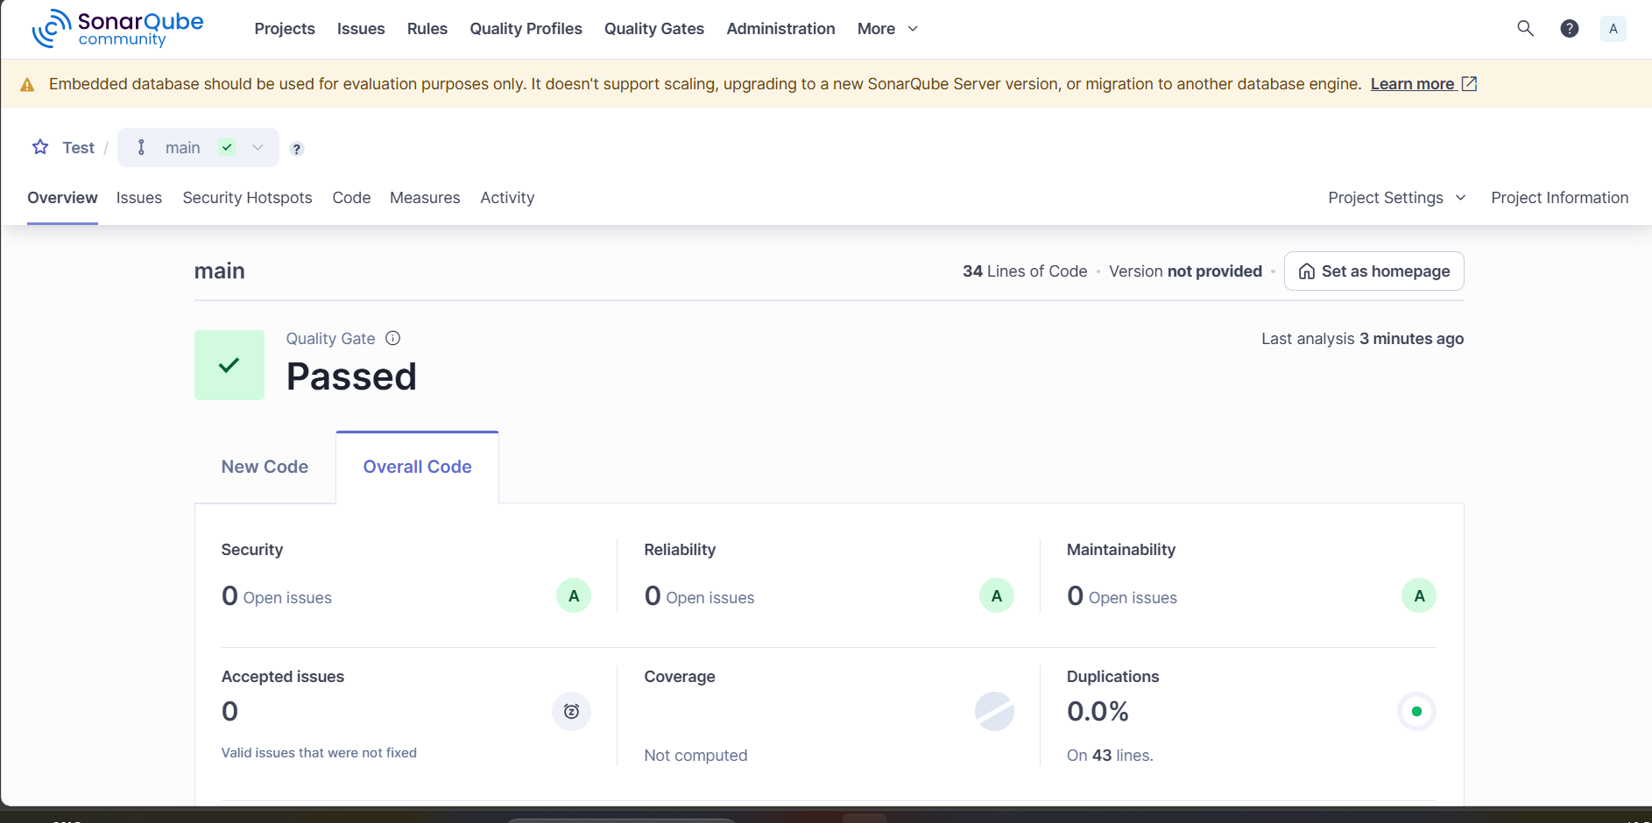

stage3: Slack Integration to send the alerts to slack.

URL: <https://github.com/betawins/hiring-app.git>

